UNIVERSITY INSTITUTE OF COMPUTING

PROJECT REPORT
ON
Project name: Employee Details Record of Salary

Program Name: BCA
Subject Name/Code: Fundamental of Data Science (25CAP-122)

Submitted by: Submitted to:
Name: Arun Saini Name: Gagandeep Chawla
UID: 25BCD10196 Designation:
Section: 25BCD-3A

Project Report: Employee Details Record of Salary

1. Title:
Employee Details Record of Salary.

2. Aim of the Project:
To manage and organize employee details efficiently.

3. Objective:
To store, update and retrieve employee information such as id, salary, job title and residence accurately and efficiently.

4. Tools and Technologies Used:
Microsoft Excel (Pivot table, Conditional formatting, Pie chart and Bar graph)

5. System Requirements:
Operating System: Windows 10 or above
Hardware: 4gb RAM
Software: Microsoft Excel 2016 or later

6. Algorithm / Logic:
1. Collect employee performance data.
2. Organize in Excel tables.
3.Apply formulas to calculate efficiency.
4.Use conditional formatting for insights.
5.Create visual charts to compare performance.

7. Code Overview
1. Salary_in_USD : Salary * Conversion_Rate
Where Conversion_Rate depends on the currency as follows:
- USD → 1
- GBP → 1.28
- EUR → 1.10
- INR → 1/83
2. Grand Total Salary : =sum(G2:G14)

8. Screenshots/ Output:

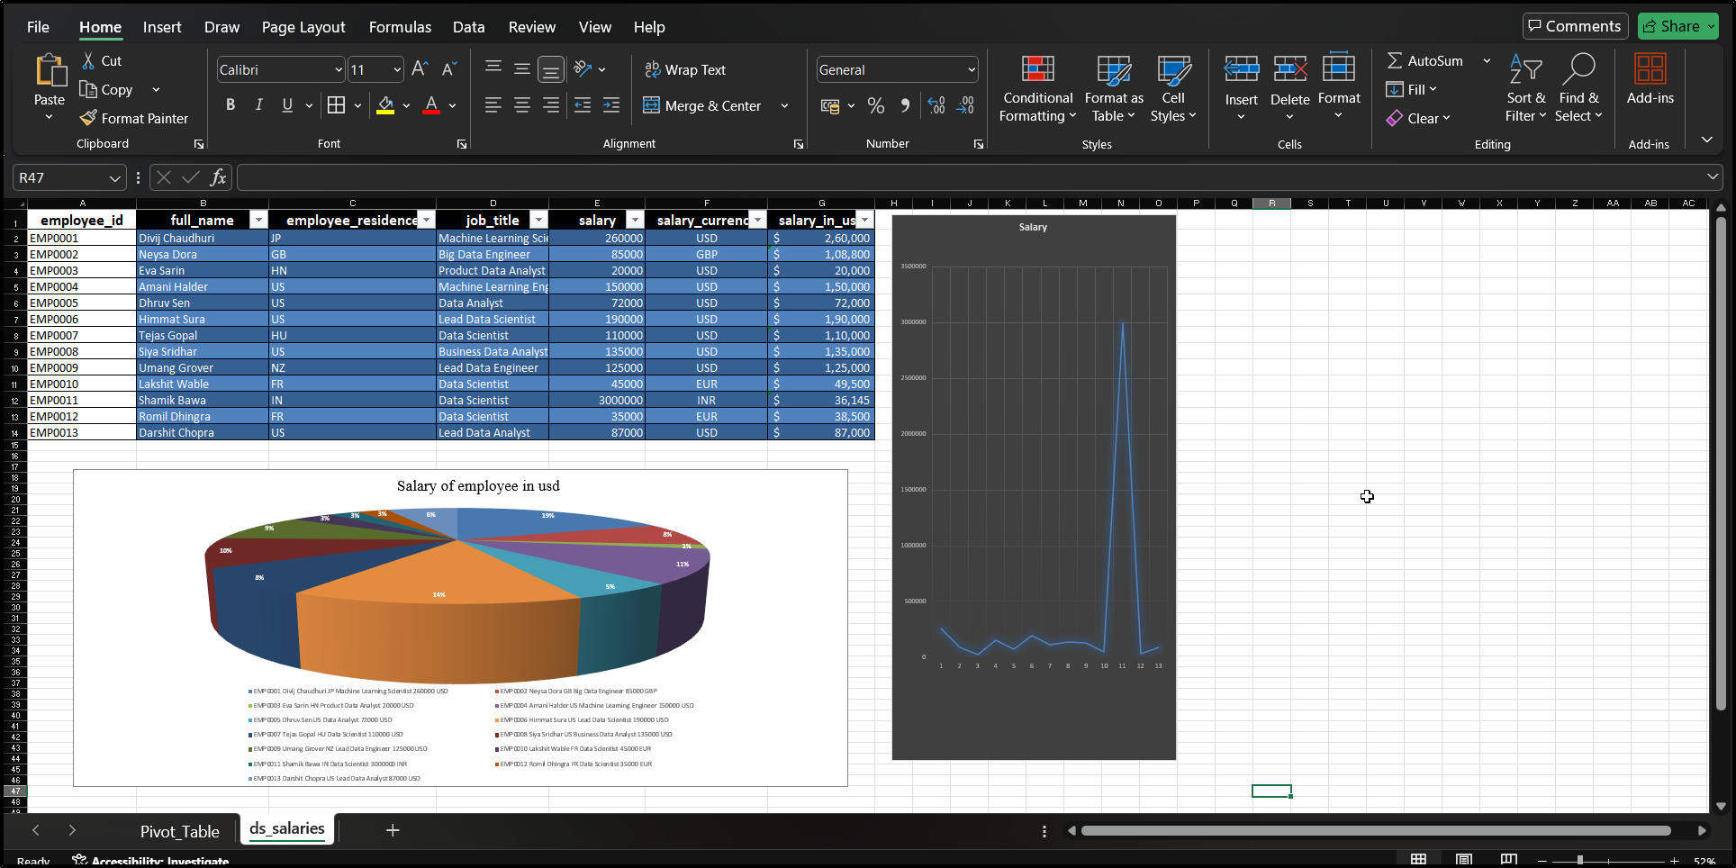
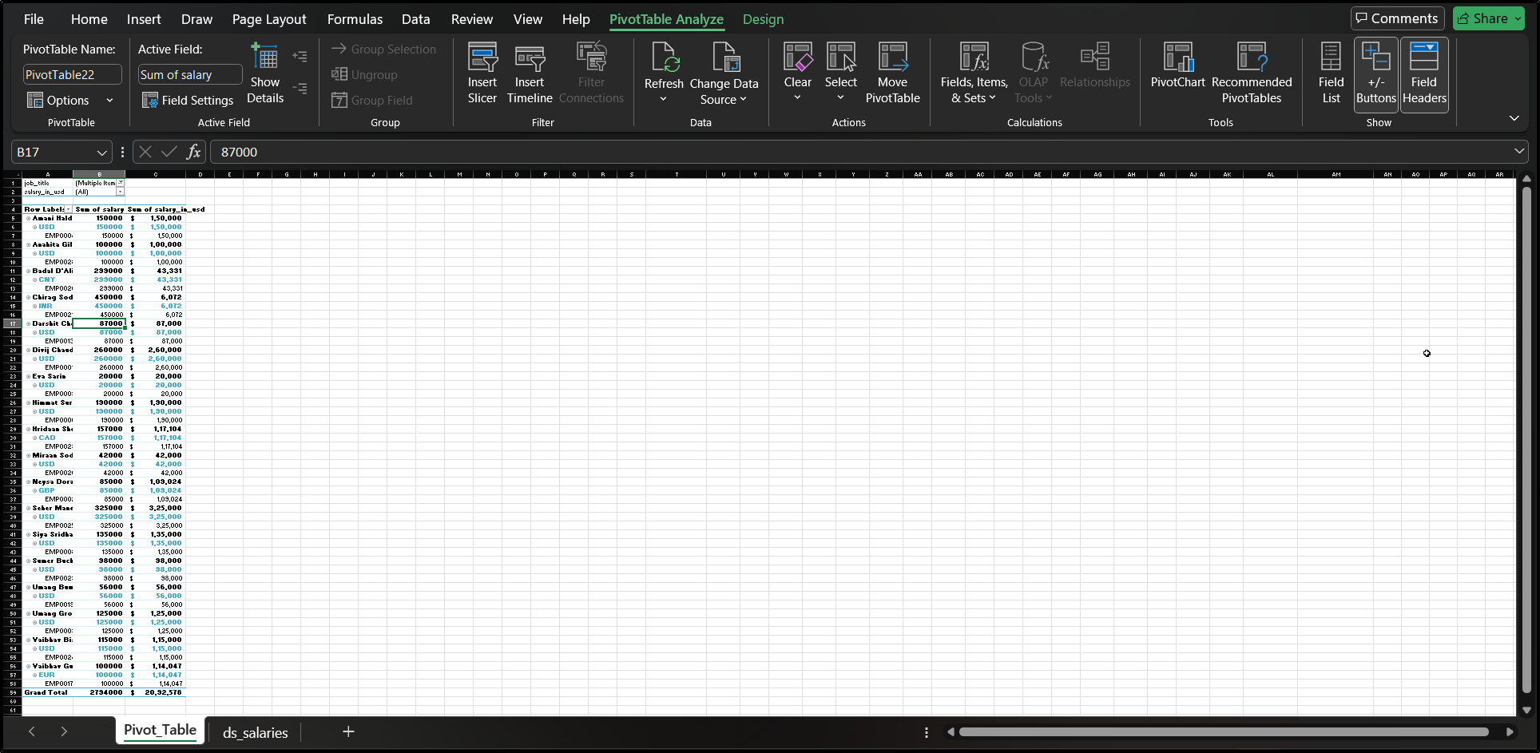

9. Project Report Link:
GITHUB LINK: https://github.com/arunneeku2006-star/Employee-Details-Record-of-Salary.git
LINKEDIN LINK: https://www.linkedin.com/posts/arun-neeku-48463a376_employee-details-record-of-salary-activity-7391873914664271873-dMyR?utm_source=social_share_send&utm_medium=android_app&rcm=ACoAAFz_oSQB_xUKJJTmIx5v8RHy_DFeXWZmtms&utm_campaign=whatsapp

10. Conclusion:
This project successfully automates the conversion of salaries into USD, ensuring accuracy and consistency in global salary analysis. It simplifies comparison across countries and enhances data reliability using Excel formulas and Python integration for efficient financial reporting.
11. Learning Outcomes:
- Gained understanding of currency conversion and its importance in global data analysis.
- Learned to use Excel formulas for automated calculations.
- Improved knowledge of data standardization techniques.
- Enhanced ability to create accurate and automated financial reports.
12. References:
- Class Notes – Fundamental of Data Science
- Microsoft Excel Documentation
- Online tutorials on Excel data visualization

